4.6.12 Tessellation
# Source: AI Source: Provided by: [Data Path: Persons Table -> ID Column: 1, Name_En Column: Motasem Essam] -> From: [ChatGPT] on [7/25/2026]
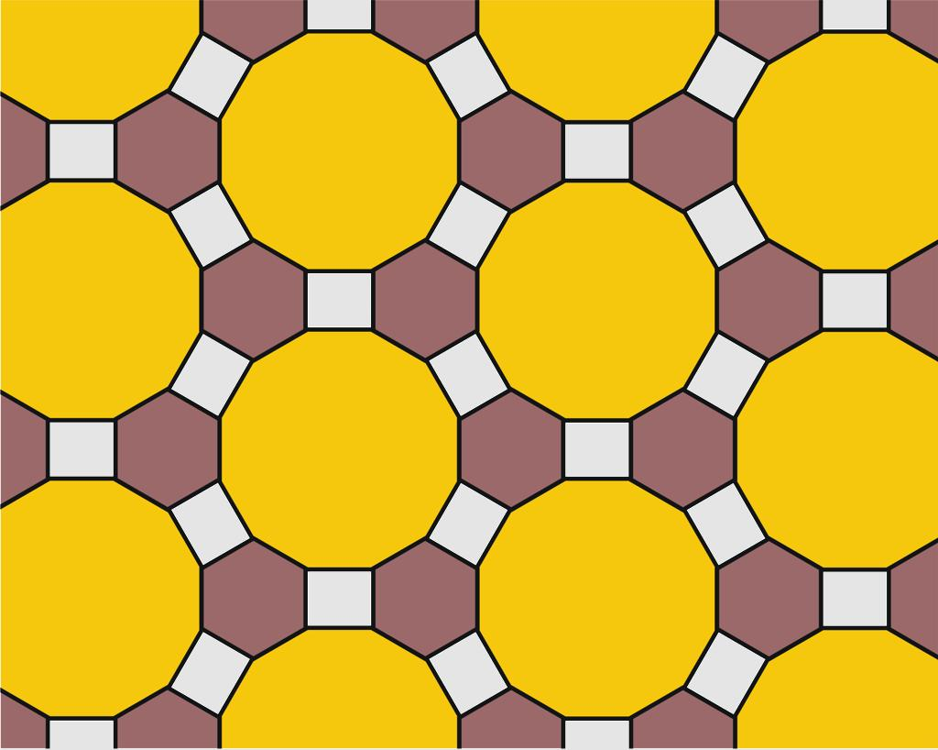
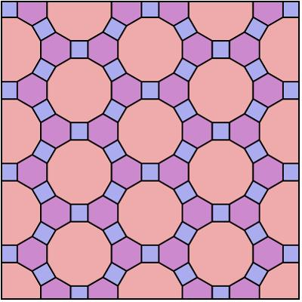
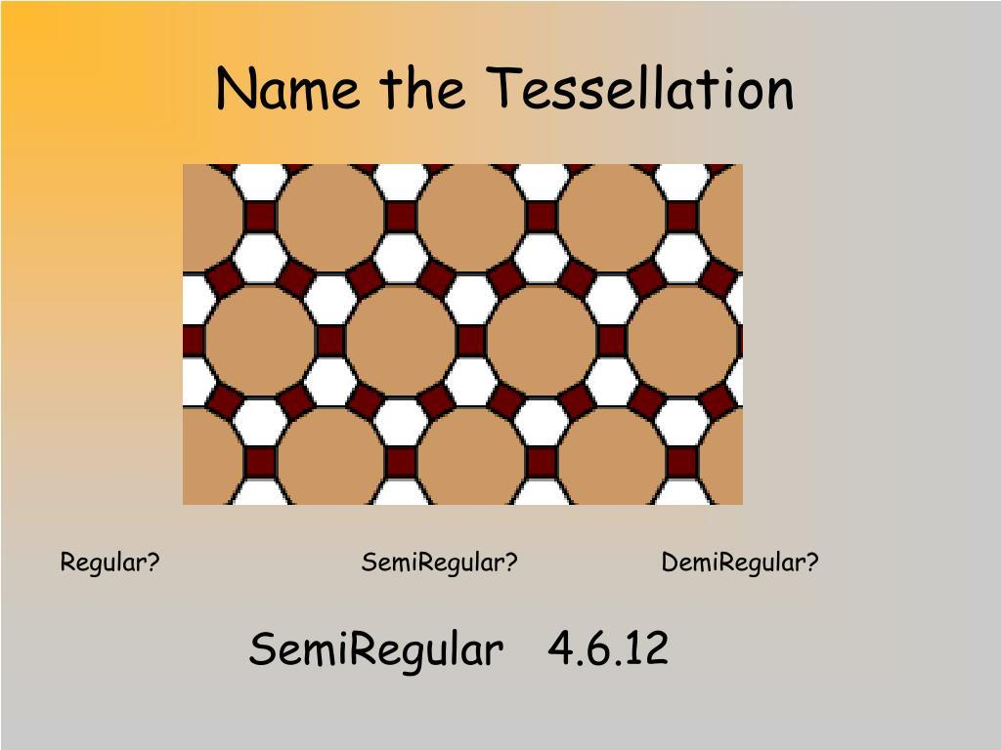
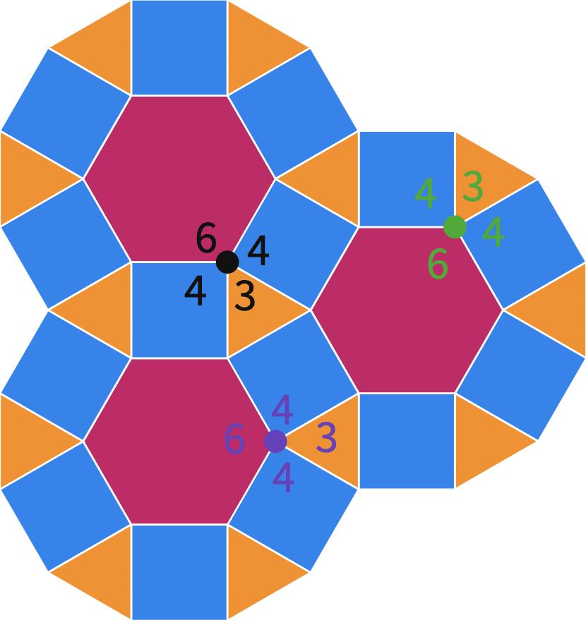
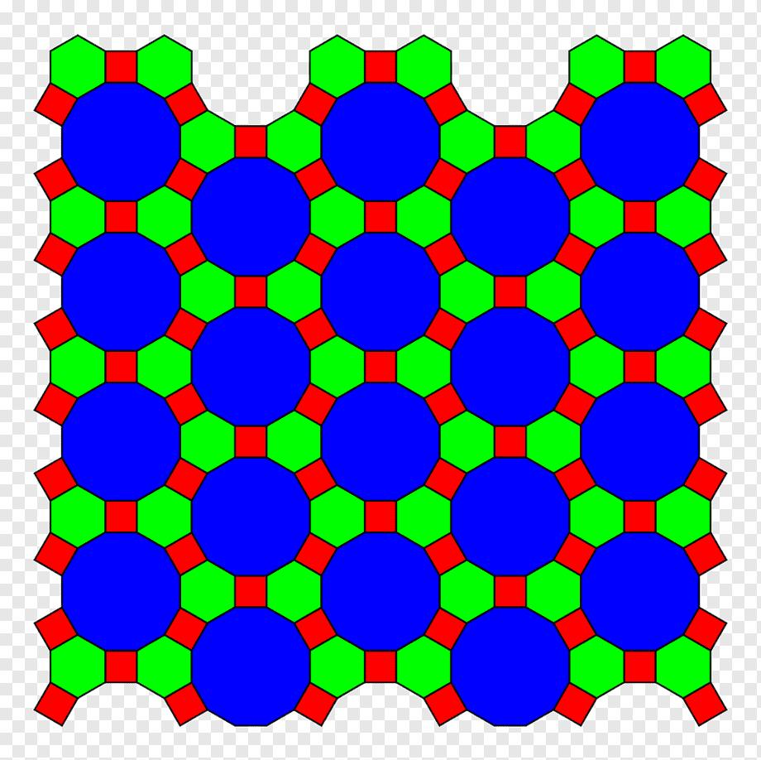

Definition
# Source: AI Source: Provided by: [Data Path: Persons Table -> ID Column: 1, Name_En Column: Motasem Essam] -> From: [ChatGPT] on [7/25/2026]
The 4.6.12 tessellation is a semi-regular (Archimedean) tessellation of the Euclidean plane composed of squares, regular hexagons, and regular dodecagons.
Its vertex configuration is:
$$\boxed{4.6.12}$$
This means that, around every vertex, the polygons occur in the cyclic order:
Square → Hexagon → Dodecagon

Basic Structure
# Source: AI Source: Provided by: [Data Path: Persons Table -> ID Column: 1, Name_En Column: Motasem Essam] -> From: [ChatGPT] on [7/25/2026]
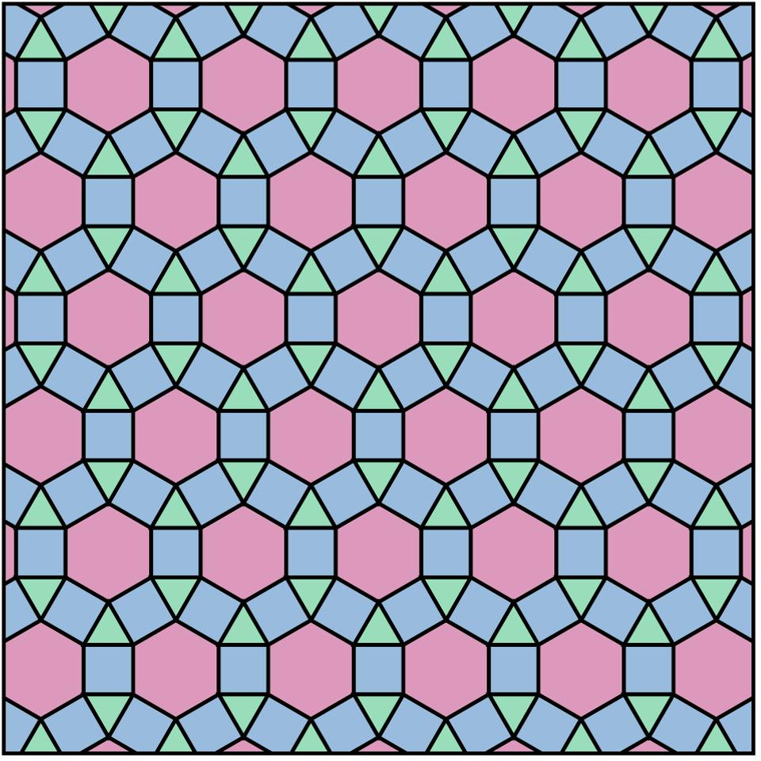
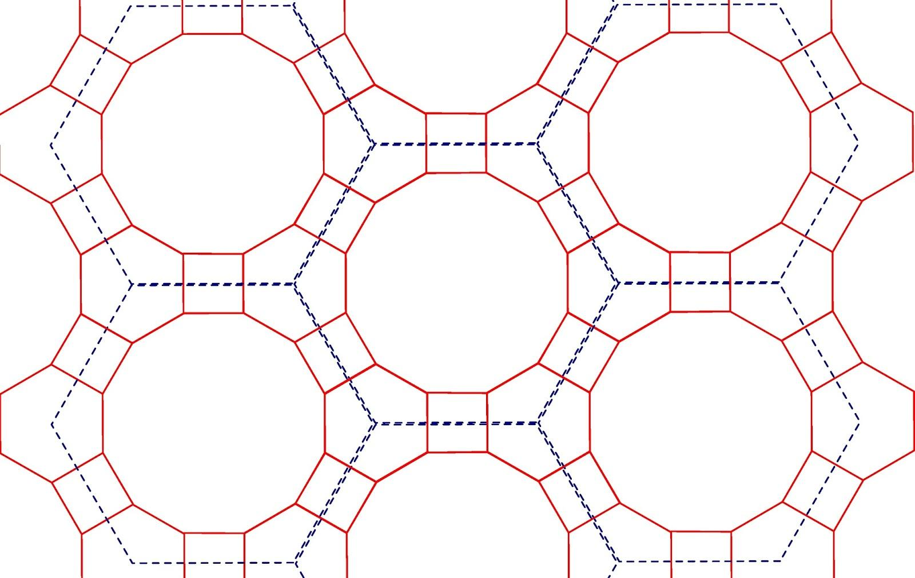
The repeating pattern contains:
- large regular dodecagons
- regular hexagons
- small regular squares
Each vertex connects exactly one of each polygon.

Classification
# Source: AI Source: Provided by: [Data Path: Persons Table -> ID Column: 1, Name_En Column: Motasem Essam] -> From: [ChatGPT] on [7/25/2026]
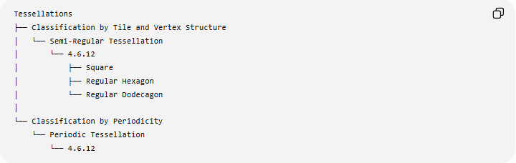
Tessellations
├── Classification by Tile and Vertex Structure
│ └── Semi-Regular Tessellation
│ └── 4.6.12
│ ├── Square
│ ├── Regular Hexagon
│ └── Regular Dodecagon
│
└── Classification by Periodicity
└── Periodic Tessellation
└── 4.6.12
Therefore:
$$\boxed{\text{4.6.12 is Semi-Regular and Periodic}}$$

Fundamental Elements
# Source: AI Source: Provided by: [Data Path: Persons Table -> ID Column: 1, Name_En Column: Motasem Essam] -> From: [ChatGPT] on [7/25/2026]
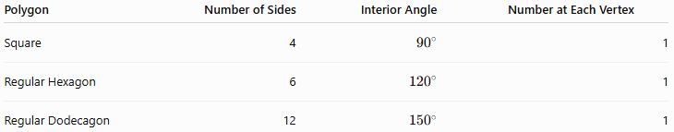
Polygon | Number of Sides | Interior Angle | Number at Each Vertex
Square | 4 | $${90}^{∘}$$ | 1
Regular Hexagon | 6 | $${120}^{∘}$$ | 1
Regular Dodecagon | 12 | $${150}^{∘}$$ | 1
Thus, three polygons meet at every vertex:
$$\boxed{1\text{ square}+1\text{ hexagon}+1\text{ dodecagon}}$$

Vertex Angle Verification
# Source: AI Source: Provided by: [Data Path: Persons Table -> ID Column: 1, Name_En Column: Motasem Essam] -> From: [ChatGPT] on [7/25/2026]
The interior angles are:
Square
$$θ_{4}=\frac{\left(4-2\right){180}^{∘}}{4}={90}^{∘}$$
Hexagon
$$θ_{6}=\frac{\left(6-2\right){180}^{∘}}{6}={120}^{∘}$$
Dodecagon
$$θ_{12}=\frac{\left(12-2\right){180}^{∘}}{12}={150}^{∘}$$
Therefore, around every vertex:
$${90}^{∘}+{120}^{∘}+{150}^{∘} \\ =\boxed{{360}^{∘}}$$
So the three polygons fit together exactly without gaps or overlaps.

Vertex Configuration
# Source: AI Source: Provided by: [Data Path: Persons Table -> ID Column: 1, Name_En Column: Motasem Essam] -> From: [ChatGPT] on [7/25/2026]
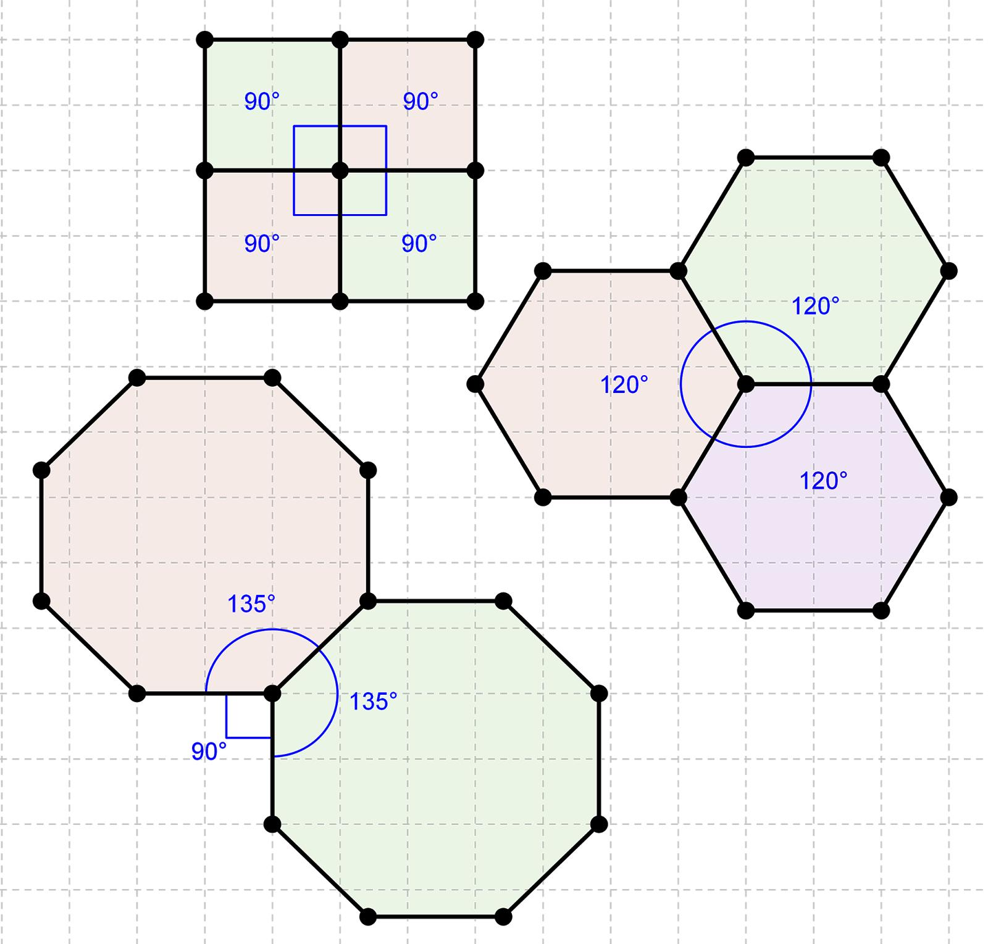
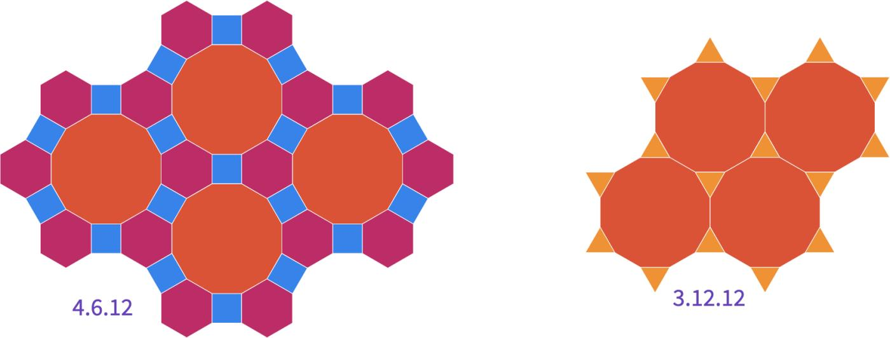
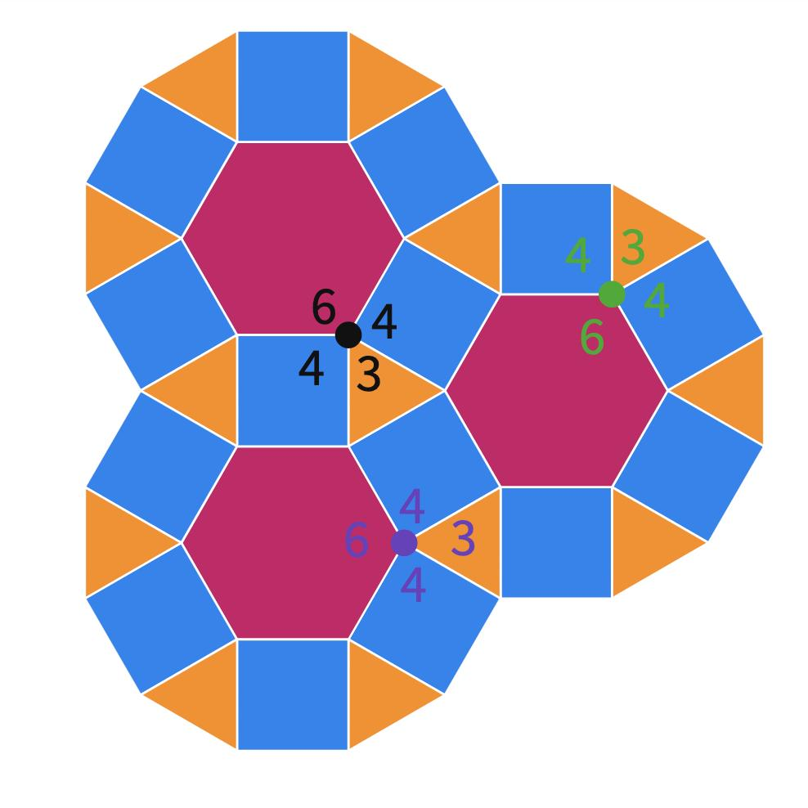
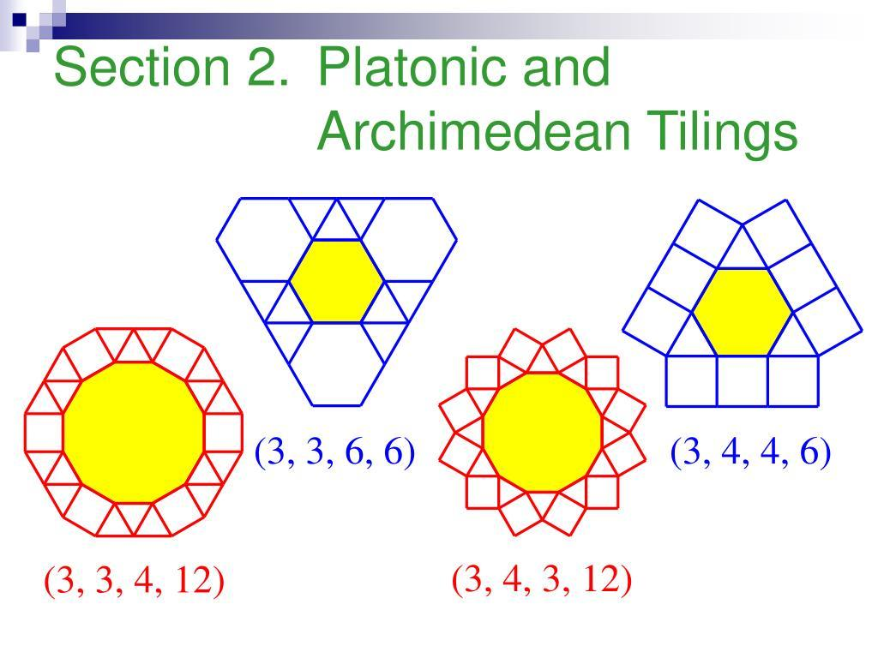
The notation
$$\boxed{4.6.12}$$
records the number of sides of the polygons encountered cyclically around a vertex:
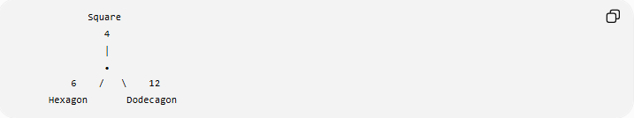
Square
4
│
•
6 / \ 12
Hexagon Dodecagon
The cyclic order is:
$$\boxed{4→6→12}$$
Each polygon type occurs exactly once around the vertex.

Why It Is Semi-Regular
# Source: AI Source: Provided by: [Data Path: Persons Table -> ID Column: 1, Name_En Column: Motasem Essam] -> From: [ChatGPT] on [7/25/2026]
The $4.6.12$tessellation satisfies the defining properties of a semi-regular tessellation:
- All tiles are regular polygons.
- Three different polygon types are used.
- The same vertex configuration occurs at every vertex.
- The polygons meet edge-to-edge.
- There are no gaps or overlaps.
Therefore:
$$\boxed{\text{4.6.12 is a Semi-Regular Tessellation}}$$

Why It Is Not Regular
# Source: AI Source: Provided by: [Data Path: Persons Table -> ID Column: 1, Name_En Column: Motasem Essam] -> From: [ChatGPT] on [7/25/2026]
A regular tessellation uses only one type of regular polygon.
The $4.6.12$tessellation uses:
- Squares
- Regular hexagons
- Regular dodecagons
Therefore:
$$\boxed{\text{4.6.12 is not a Regular Tessellation}}$$

Periodicity
# Source: AI Source: Provided by: [Data Path: Persons Table -> ID Column: 1, Name_En Column: Motasem Essam] -> From: [ChatGPT] on [7/25/2026]
The arrangement repeats throughout the Euclidean plane through translations.
Therefore:
$$\boxed{\text{4.6.12 is Periodic}}$$
Its combined classification is:
$$\boxed{\text{Semi-Regular + Periodic}}$$

Mathematical Representation
# Source: AI Source: Provided by: [Data Path: Persons Table -> ID Column: 1, Name_En Column: Motasem Essam] -> From: [ChatGPT] on [7/25/2026]
The general interior-angle formula for a regular $n$-gon is:
$$θ_{n}=\frac{\left(n-2\right){180}^{∘}}{n}$$
For $4.6.12$:
$$θ_{4}+θ_{6}+θ_{12}={360}^{∘} \\ \boxed{{90}^{∘}+{120}^{∘}+{150}^{∘}={360}^{∘}}$$
This confirms that the vertex can be completely filled.

Equivalent Compact Notation
# Source: AI Source: Provided by: [Data Path: Persons Table -> ID Column: 1, Name_En Column: Motasem Essam] -> From: [ChatGPT] on [7/25/2026]
Because each polygon occurs once, there is no repeated exponent form needed.
The configuration is simply:
$$\boxed{4.6.12}$$
It represents:
- $4$→ one square
- $6$→ one hexagon
- $12$→ one dodecagon

Important Structural Feature
# Source: AI Source: Provided by: [Data Path: Persons Table -> ID Column: 1, Name_En Column: Motasem Essam] -> From: [ChatGPT] on [7/25/2026]
The three polygons have progressively larger interior angles:
$${90}^{∘}<{120}^{∘}<{150}^{∘}$$
Their angles complement each other:
$${90}^{∘}+{120}^{∘}+{150}^{∘}={360}^{∘}$$
Thus, each vertex is occupied by exactly three different regular polygons.

Comparison with $3.12.12$
# Source: AI Source: Provided by: [Data Path: Persons Table -> ID Column: 1, Name_En Column: Motasem Essam] -> From: [ChatGPT] on [7/25/2026]
Both configurations contain a regular dodecagon and have three polygons at each vertex.
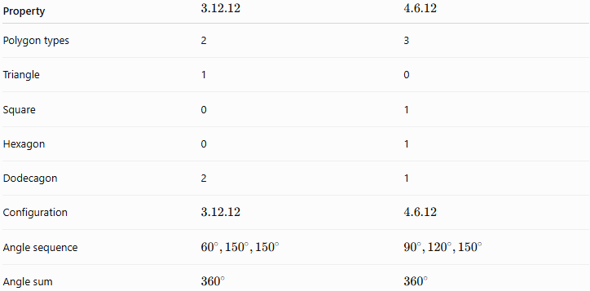
Property | $$3.12.12$$ | $$4.6.12$$
Polygon types | 2 | 3
Triangle | 1 | 0
Square | 0 | 1
Hexagon | 0 | 1
Dodecagon | 2 | 1
Configuration | $$3.12.12$$ | $$4.6.12$$
Angle sequence | $${60}^{∘},{150}^{∘},{150}^{∘}$$ | $${90}^{∘},{120}^{∘},{150}^{∘}$$
Angle sum | $${360}^{∘}$$ | $${360}^{∘}$$
Therefore:
$$\boxed{3.12.12≠4.6.12}$$

Comparison with $3.4.6.4$
# Source: AI Source: Provided by: [Data Path: Persons Table -> ID Column: 1, Name_En Column: Motasem Essam] -> From: [ChatGPT] on [7/25/2026]
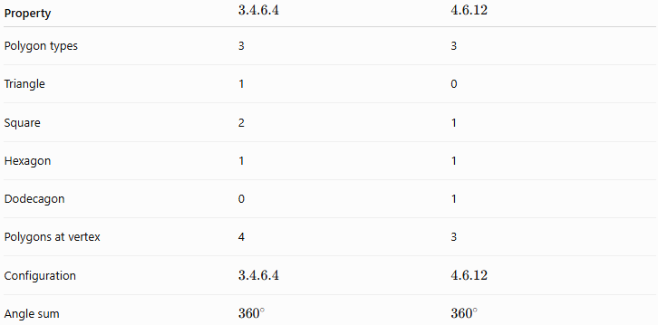
Property | $$3.4.6.4$$ | $$4.6.12$$
Polygon types | 3 | 3
Triangle | 1 | 0
Square | 2 | 1
Hexagon | 1 | 1
Dodecagon | 0 | 1
Polygons at vertex | 4 | 3
Configuration | $$3.4.6.4$$ | $$4.6.12$$
Angle sum | $${360}^{∘}$$ | $${360}^{∘}$$

Key Properties
# Source: AI Source: Provided by: [Data Path: Persons Table -> ID Column: 1, Name_En Column: Motasem Essam] -> From: [ChatGPT] on [7/25/2026]
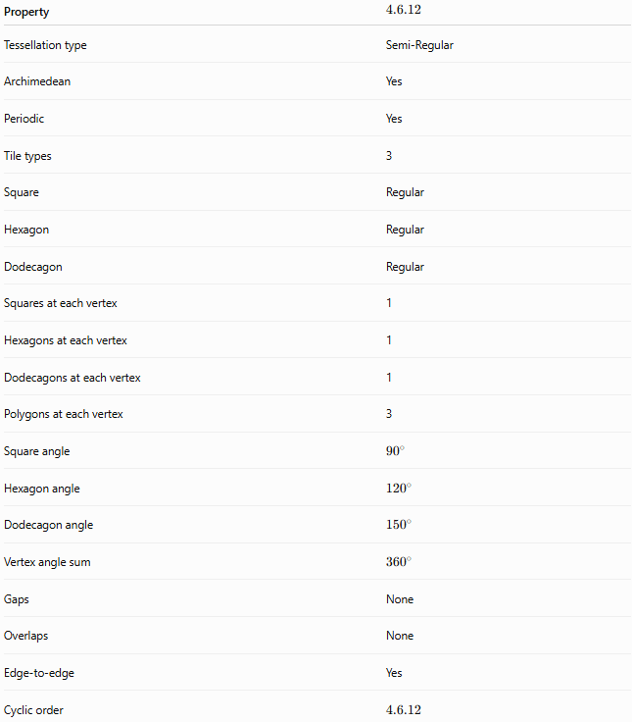
Property | $$4.6.12$$
Tessellation type | Semi-Regular
Archimedean | Yes
Periodic | Yes
Tile types | 3
Square | Regular
Hexagon | Regular
Dodecagon | Regular
Squares at each vertex | 1
Hexagons at each vertex | 1
Dodecagons at each vertex | 1
Polygons at each vertex | 3
Square angle | $${90}^{∘}$$
Hexagon angle | $${120}^{∘}$$
Dodecagon angle | $${150}^{∘}$$
Vertex angle sum | $${360}^{∘}$$
Gaps | None
Overlaps | None
Edge-to-edge | Yes
Cyclic order | $$4.6.12$$

Relationship to the Eight Semi-Regular Tessellations
# Source: AI Source: Provided by: [Data Path: Persons Table -> ID Column: 1, Name_En Column: Motasem Essam] -> From: [ChatGPT] on [7/25/2026]
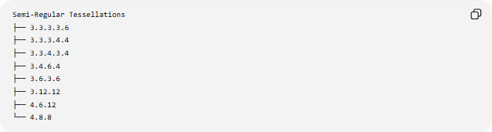
Semi-Regular Tessellations
├── 3.3.3.3.6
├── 3.3.3.4.4
├── 3.3.4.3.4
├── 3.4.6.4
├── 3.6.3.6
├── 3.12.12
├── 4.6.12
└── 4.8.8
The $4.6.12$tessellation is therefore one of the eight Archimedean tessellations of the Euclidean plane.

Key Points
# Source: AI Source: Provided by: [Data Path: Persons Table -> ID Column: 1, Name_En Column: Motasem Essam] -> From: [ChatGPT] on [7/25/2026]
- $4.6.12$is a semi-regular (Archimedean) tessellation.
- It uses:
  - Squares
  - Regular hexagons
  - Regular dodecagons
- Exactly three polygons meet at every vertex.
- Each polygon type occurs once.
- The cyclic configuration is:
$$\boxed{4→6→12}$$
- The interior angles are:
$${90}^{∘}, {120}^{∘}, {150}^{∘}$$
- Their sum is:
$$\boxed{{360}^{∘}}$$
- It is also periodic.

Conclusion
# Source: AI Source: Provided by: [Data Path: Persons Table -> ID Column: 1, Name_En Column: Motasem Essam] -> From: [ChatGPT] on [7/25/2026]
The 4.6.12 tessellation is a semi-regular, periodic tessellation formed by squares, regular hexagons, and regular dodecagons. At every vertex, exactly one of each polygon meets in the cyclic configuration
$$\boxed{4.6.12}$$
and their interior angles satisfy
$$\boxed{{90}^{∘}+{120}^{∘}+{150}^{∘}={360}^{∘}}$$
allowing the three regular polygons to cover the Euclidean plane completely without gaps or overlaps.

